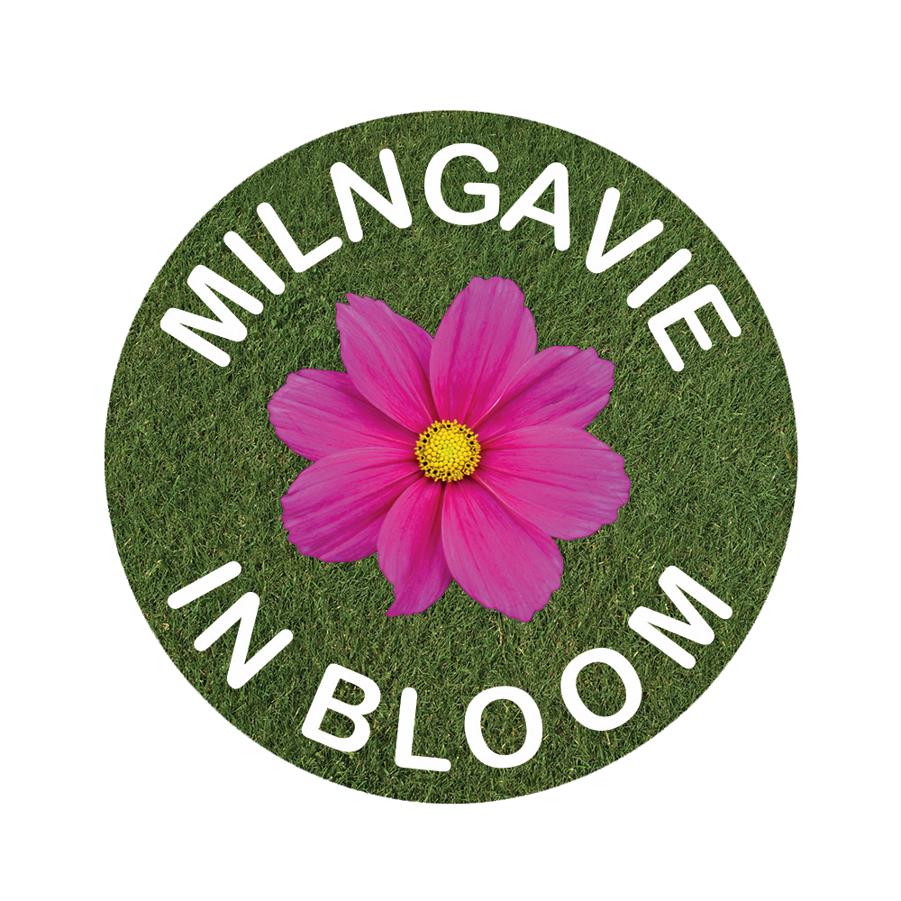
MEMBERSHIP APPLICATION
Membership of Milngavie in Bloom is free and open to anyone aged 18 and over who lives in or near Milngavie. There are 3 categories of membership: Gardening, Clean Sweep (litter picking) and Friend but you can be in more than one category if you wish.

All you have to do to join is to fill in the basic details below. You don’t need any gardening skills and signing up doesn’t commit you to anything. All we require of you is to let us know if you no longer wish to be a member.

I wish to become a member of Milngavie in Bloom as (tick more than one if you wish)

Gardener ☐

Clean Sweeper ☐

Friend ☐

Name:

Postal Address:

Email Address:

Phone No (mobile preferred):

Signature and Date:

Please hand the completed form to the person who gave it to you or send it to Ian Mitchell, 43 Lynn Drive, Milngavie G62 8HL.

Unless required to do so by law, Milngavie in Bloom will not share these details with anyone else.

